Student Name | Vishnu Anand
SRN | PES1UG24CS537
Project | Multi-Cloud Cost Optimization Portal
Lab | Lab 2 – Agile Backlog Creation & Sprint Simulation in Jira
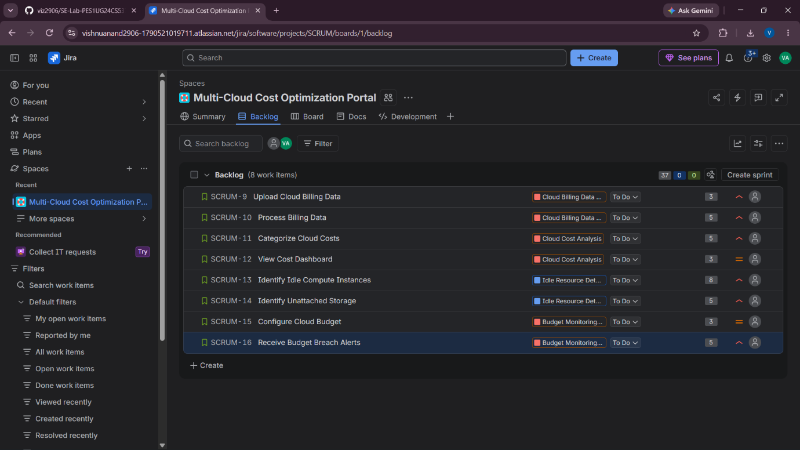
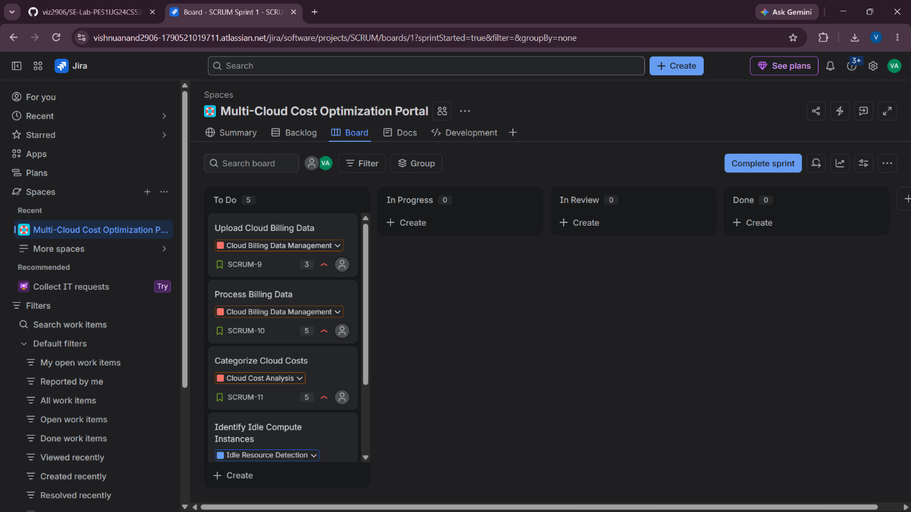
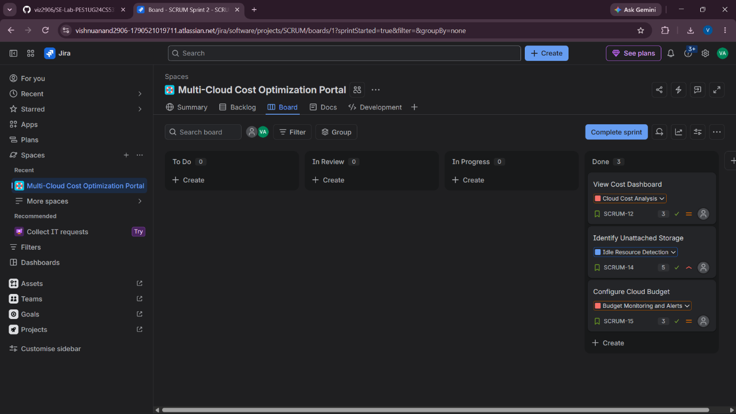
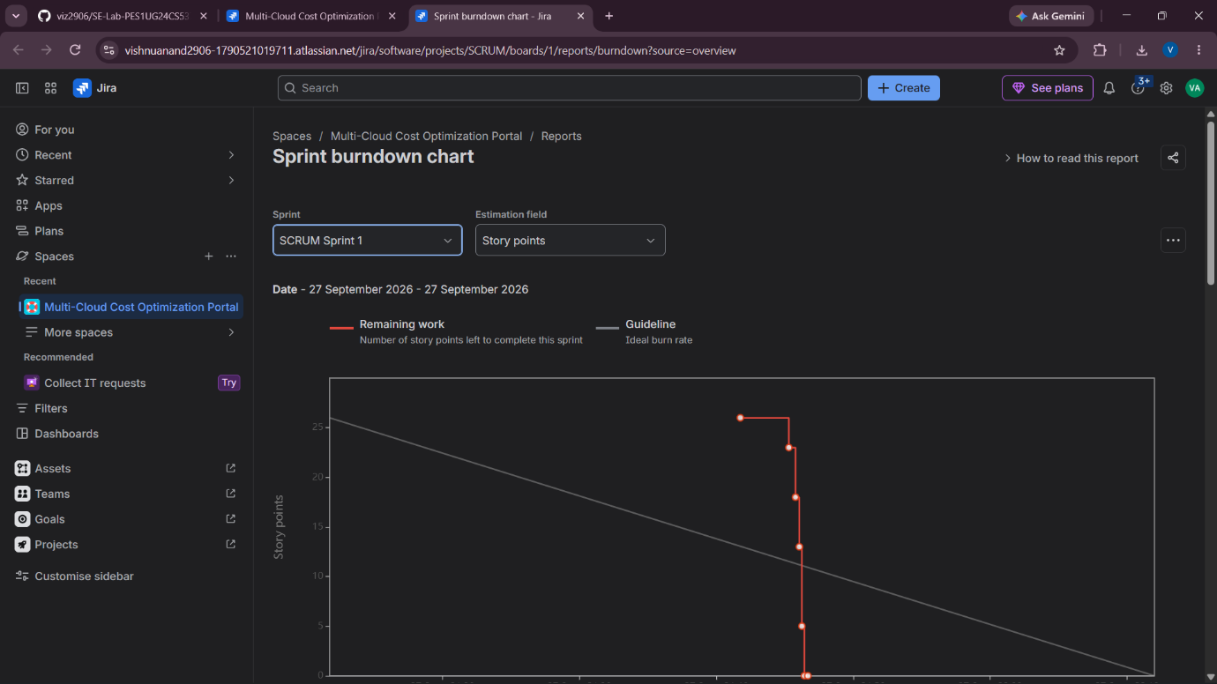

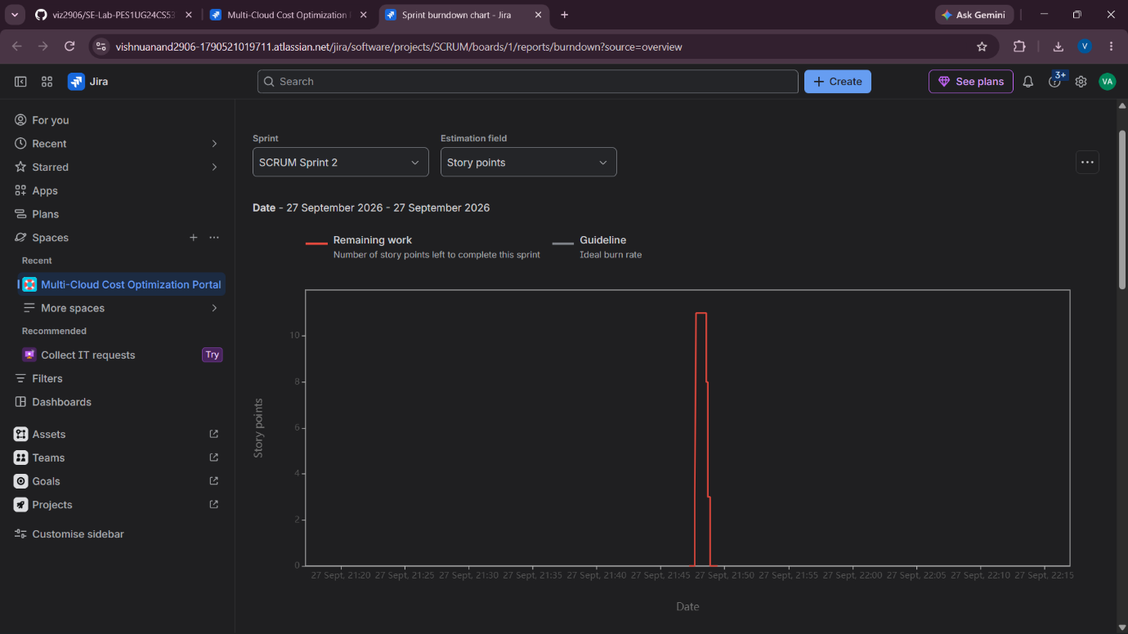
Reflection Questions :
Q1. Did your estimations reflect the actual effort?
The story point estimates reasonably reflected the relative effort of the user stories. Higher-complexity stories such as identifying idle compute instances were assigned more points, while simpler stories received fewer points. The sprint simulation helped compare the estimated complexity with the completion of the work
Q2. Was your backlog well-prioritized?
Yes. Core cloud billing, cost analysis, idle resource detection and budget alert functionality were given higher priority because they directly support the main objective of the portal. Less critical dashboard and configuration functionality was assigned lower priority.
Q3. How did your simulated sprint align with your plan?
The simulated sprints followed the planned Agile workflow. Selected user stories were moved from the backlog into the sprint and progressed from To Do to In Progress and finally Done. The two-sprint simulation allowed the planned backlog to be completed in an organized manner.
Q4. What insights did the burndown chart give about your team's capacity?
The burndown chart showed the reduction of remaining story points as the sprint progressed. It provided an indication of how quickly the planned work was being completed and helped assess whether the team's planned workload was achievable within the sprint.

